
recruitment@zoonation.co.uk
Registered Charity Number 1179510
zoonation.co.uk

Finance Manager Recruitment Pack

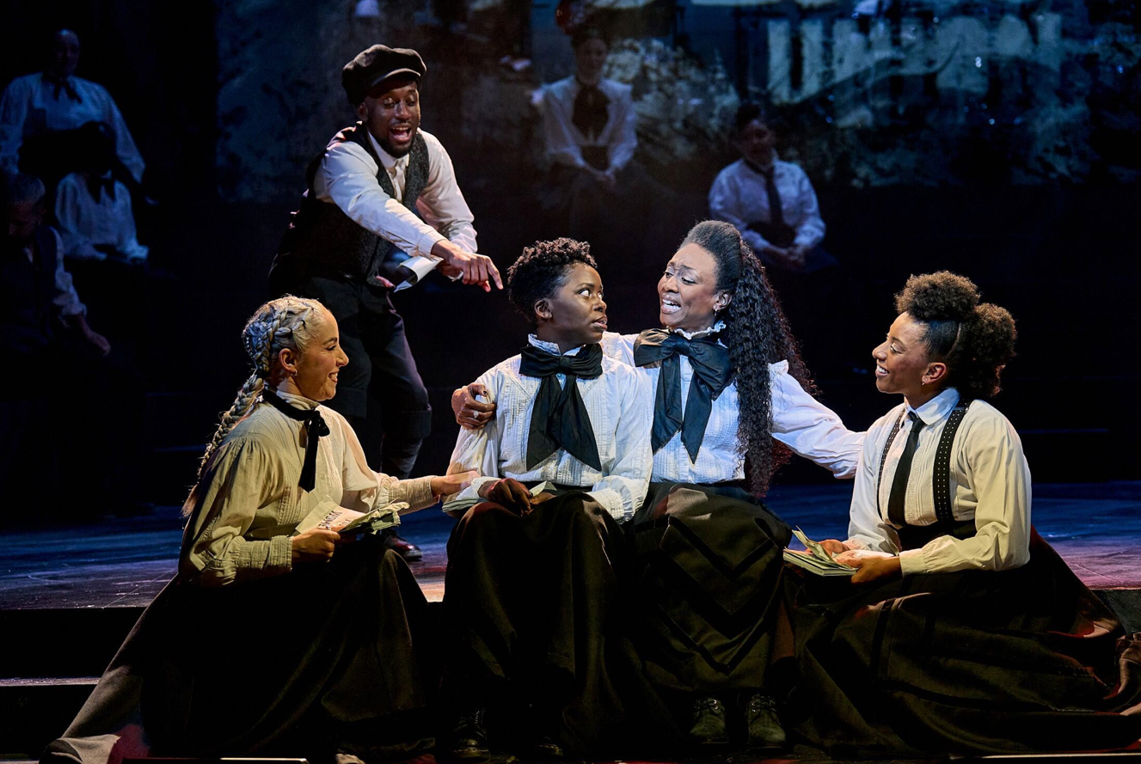
Sylvia at The Old Vic, Manuel Harlan, 2023….

Introduction

Thank you for your interest in the Finance Manager position at ZooNation: The Kate Prince Company.

This pack is designed to give you some background information on our company and outline what we’re looking for. You can find out more about us by visiting www.zoonation.co.uk

In 2022 ZooNation celebrated its 20-year anniversary. Throughout those two decades we have been driven by a belief that artists, young people, and audiences should be able to develop their career, talent and appreciation of Hip Hop inspired theatre without judgement or barriers.
As a National Portfolio Organisation (now in our third round of Arts Council England funding), it is an exciting time to join ZooNation as we are making further plans to deliver an dynamic programme of work that embodies our mission and serves our loyal and ever-growing audiences under the guidance of Kate Prince and our first ever Associate Artistic Director Danielle ‘Rhimes’ Lecointe. This autumn groundbreaking musical Sylvia tours the UK, including 5 performances at the Royal Albert Hall, followed by the return of our Christmas show Ebony Scrooge to Sadler’s Wells East. In 2027 our sell out show The Mad Hatter’s Tea Party returns to Royal Ballet and Opera. We have a talented Youth Company, talent development programmes for young artists, run a Saturday dance academy and deliver workshops and programmes in schools nationally. Our impact relies on artistic excellence and supporting the next generation of theatre makers, as we continue to push boundaries with our work.

The Finance Manager is a new key role in the ZooNation team, responsible for the smooth running of financial operations and management.

We are looking for a self-motivated individual with excellent attention to detail who can lead on our financial operations and management. We are looking for individuals who are experienced at financial management, ideally within the charity and performing arts sector, and who enjoy working in a team. You will be responsible for all areas of financial management and processing, working closely with the General Manager, Executive Director and wider team

To apply
Please send your current CV, Equal Opportunities Monitoring Form, and a short personal statement outlining your skills, experience, and knowledge and how you would deliver the role with attention to the outlined responsibilities and personal specifications.

Please respond by Monday 18 May 12pm to recruitment@zoonation.co.uk with the subject title Finance Manager.

Shortlisted candidates should be available the weeks beginning 25th May and 1st June for an interview.

We are an equal opportunities employer and encourage applications that reflect the diversity of society and welcome applications from individuals currently under-represented in the arts.

We are committed to ensuring applicants have an equitable experience when applying for the role, attending an interview, or working for our company, so please make us aware of any support you need. If you require the pack in large print, or alternative format or wish to discuss any queries please contact recruitment@zoonation.co.uk who will be happy to make necessary arrangements.

ZooNation: The Kate Prince Company

We are ground-breaking storytellers using original music and dance to inspire the next generation of theatre goers and makers.

We create narrative work with original music, writing and dance informed by Hip Hop culture which we tour nationally. We fortify this work with an extensive programme of engagement and talent development, working with different communities and young artists to increase their skills, knowledge, and confidence in our styles of dance theatre.
Our work challenges preconceptions about musical theatre, dance and Hip Hop culture. We seek to inspire a generation of theatre makers and goers through the creation of enchanting and powerful stories that do not exclude, patronise, or intimidate.

Artistic Director Kate Prince MBE founded ZooNation in 2002 with a vision to create innovative, entertaining, and accessible pieces of narrative Hip Hop dance theatre that provide a platform for dance artists from non-conventional dance backgrounds. Surrounded by ballet, contemporary, jazz, and musical theatre dancers, she found there was a distinct lack of opportunity for ‘street’ dancers to take to the stage. Kate set up ZooNation to address this inequality.

Led by Kate Prince, we create ground-breaking theatre that fuses dance, original music, and compelling storytelling for audiences nationally to create witty, innovative, relevant, and entertaining work inspired by Hip Hop culture that draws on a kaleidoscope of influences including Hip Hop.
We believe it is crucial to capture the imagination of the next generation of talent and audience and ensure our productions and training remain relevant but inspirational to young people and artists at all stages of their career.

We invest in talent, supporting individuals to pursue their personal career goals as they mature. We want to continue to play a vital role in setting the standard for professional practice for artists working in Hip Hop with our work providing a platform for dance artists from non-conventional dance backgrounds.
As a female led company, we strongly believe in celebrating and supporting female talent and using our work to highlight issues affecting women.

We understand that our future is as a developer of talent. We hope to increasingly use our experience, knowledge, and platform to create greater, sustained opportunities for artists (especially those that experience racism as a barrier) to develop and share their work and build their careers.

We have gained significant recognition of our artistic excellence through a variety of associateships which reflect the diverse facets of our work as artistic leaders, a trailblazing company and an enabler of the next generation of talent.
In 2024 ZooNation won the Critic's Circle National Dance Award for Best Midscale Company.

Our portfolio of productions includes:

- Into the Hoods
Into the Hoods was the first ever Hip Hop dance show and the longest running dance show in the West End’s history at its time. It re-tells classic fairy tales in our trademark innovative style – combining comedy with Hip Hop dance, physical theatre, and a strong narrative. It opened in 2008 at London’s Novello Theatre and has since toured nationally.
- Some Like It Hip Hop
Some Like It Hip Hop is a story of love, mistaken identity, and female revolution. Influenced by the themes from classic movies Some Like It Hot, US hit show Mad Men and Shakespeare’s Twelfth Night Some Like It Hip Hop is a complicated comical tale that has entertained audiences across the country.
- Groove on Down the Road
This production, initially performed at Southbank Centre by ZooNation Youth Company, puts our unique twist on the well-known tale of The Wizard of Oz, with the underlying theme being the importance of creative subjects in the classroom. This production has been successfully remounted in Wales, Wolverhampton, and Birmingham with a cast of young people from the region.
- The Mad Hatters Tea Party
The Mad Hatter’s Tea Party had an original sell-out premiere run at Royal Opera and Ballet House in 2014 and was reimagined for the unique space of the Roundhouse. It returned in 2024 for a second sell out run at Royal Opera and Ballet. True to form, this dance adventure uses our energetic and accessible style to reinvent Lewis Carroll’s original story in an imaginative, 21st-century way, exploring perceptions of mental illness and what counts as ‘normal’.
- Sylvia
Sylvia returned to The Old Vic in 2023 for an extended three month run and was nominated for three Olivier Awards. Best New Musical, Best Theatre Choreographer - Kate Prince, Best Actress in a Supporting Role in a Musical - Beverley Knight - WINNER.
This revolutionary story celebrates the life of Sylvia Pankhurst - feminist, activist, pacifist, socialist, rebel - the lesser-known Pankhurst at the heart of the Suffragette movement, who changed the lives of working women and men across the world.
- Tales of the Turntable
Tales of the Turntable is a ZooNation Youth Company production commissioned by Southbank Centre performed at Queen Elizabeth Hall in Summer 2019. Tales of the Turntable invites the audience to time travel with introverted young DJ, Eric, and his grandfather as they (re) discover the music and dance that create the foundations for music today.
- Message In A Bottle
Message In A Bottle fuses ZooNation’s dynamic dance storytelling with Sting’s iconic hits, reimagined by Tony and Grammy Award-winner Alex Lacamoire. Created by Kate Prince, premiering at Sadler’s Wells’ Peacock Theatre in 2020, the show has toured the UK and internationally, reaching Zurich, Sydney, the Netherlands, and Broadway. In 2024 it was adapted into a feature film, released in UK cinemas, broadcast on PBS in the U.S., and streamed worldwide, capturing ZooNation’s choreography and Sting’s music in a groundbreaking, immersive format.
- Ebony Scrooge
A brand-new production co-produced by Sadler’s Wells, premiering this Christmas at the new Sadler’s Wells East in Stratford. Ebony Scrooge is a vibrant and contemporary adaptation of A Christmas Carol, reimagined with ZooNation’s signature style, bold storytelling and dynamic choreography. Created by our Associate Artistic Director, Dannielle “Rhimes” Lecointe, this production promises to bring fresh energy and vision to a timeless classic.

ZooNation Finance Manager Job Description

Job Title: Finance Manager
Salary: £40,500 p/a (Pro-rata £16,200 @ 2 days p/w)
Hours: 7.5 hours per day (inc. 1 hour paid lunch)
Enhanced Sick leave: 4 weeks full pay, followed by 4 weeks half pay, followed by Statutory Sick Pay (SSP)
Holiday pay: 28 days + bank holidays of paid leave per annum (Pro-rata 16.5 days p/a)
Overtime: ZooNation: The Kate Prince Company does not operate paid overtime but operates flexible TOIL system
Remote working: We offer remote and flexible working but also have an office in Islington, London available for all staff
Hours of work: 2 days per week
Notice Period: 3 months

Responsible to: The Co-Executive Directors
Working with: The General Manager and company budget holders

Purpose of the post

- To ensure strong and effective financial management, reporting and overview across all activities of ZooNation: The Kate Prince Company (including Touring, Engagement, ZooNation Youth Company, Agency, and core company activity)
- To ensure ZooNation: The Kate Prince Company operates efficiently and is compliant with all required legal and statutory requirements

Key responsibilities

- Prepare and monitor annual budgets with oversight from Executive Directors
- Work with the General Manager and company budget holders to reconcile department and production budgets, and provide regular data and reports from QuickBooks
- Implement effective financial systems to manage revenue and project income accurately and provide clear financial reporting
- Prepare and submit VAT returns
- Produce quarterly management accounts, cash flow and financial narrative for the board and Finance committee
- Regular review of Balance Sheet items with any necessary adjustments posted
- Manage day to day financial operations, ensuring effective financial controls are in place and implemented including posting of all financial transactions, monthly petty cash, credit cards and bank reconciliation
- Manage company payroll and pension scheme
- Manage weekly company pay run and expenses
- Regular debtor and creditor reviews
- Process and maintain records for all expenditure including, issuing invoices, and online payments
- Process and maintain records for all income, including issuing invoices, chasing overdue payments and depositing payments
- Manage the core operations budget ensuring value for money is achieved
- Prepare and contribute to financial reporting and analysis for funders
- Work with Company Accountant to produce annual financial auditing information for Companies House and Charity Commission
- Working with the company accountant and budget holders to claim TTR following on all relevant productions
- Be a bank signatory and credit card holder
- Liaise with HMRC to ensure ZooNation: The Kate Prince Company is up to date with relevant tax changes and ensure timely and accurate tax filing
- Collection and distribution of royalty payments
- Annual Gift Aid claims
- Other duties as reasonably required

Person specification

You will be a diligent individual who is enthusiastic about developing financial processes. You will be focussed on creating effective systems that contribute to delivering the company’s finances effectively. You will be comfortable working autonomously and remotely as well as with the General Manager, Executive Director and wider team.
You will be responsive, a problem solver with excellent time management and attention to detail.

Essential
- Strong knowledge of QuickBooks (or similar accounting software) and Excel
- Experience of Charity accounting
- Robust knowledge of payroll, VAT and HMRC compliance
- Experience in preparing TTR claims
- Experience of preparing annual budgets, management accounts, reports with ability to analyse and interpret complex financial data
- Excellent organisational skills and attention to detail
- Ability to work with the whole team effectively and with clarity
- Understanding of the current financial environment for the arts and charitable sector
- Commitment to equal opportunities and environmental sustainability
- Qualified or part qualified at AAT/CIMA/ACCA or equivalent

Desirable
- Dance experience and knowledge
- Understanding of the current financial environment for the arts and charitable sector
- Experience of working with a board or management committee

